SENSORY MODULATION ACTIVITIES.

- Please incorporate these sensory activities into your child’s daily routine and especially before a structured activity such as expecting them to sit still during circle time or prior to doing some table top activities.

Activity | Description of how to provide | When to provide | Effect
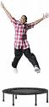  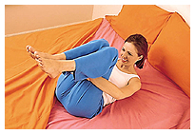  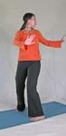      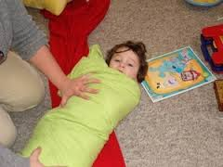  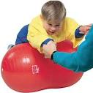  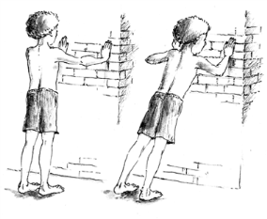    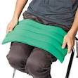  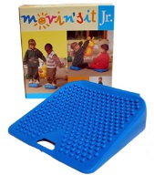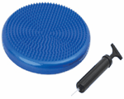    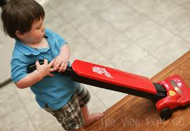   | Alerting activities  Jump and touch a point on the wall 10 times, then repeat  or use trampoline  On carpet or a mat curl up into a ball, place hands under the knees, keep the chin tucked into the chest and rock back and forth.  Count to 10, then repeat.  Stand with your back to the wall, with your feet hip width apart and about 20cm from the wall.  Twist and touch the wall behind you 5 times each side  Reach in front of you and touch the floor, then reach and stretch your arms above your head touch the wall behind you for 5 times  CALMING ACTIVITIES.  Massage.  Deep, firm massage through the child’s shoulders and her arms and fingers. The child may also find deep pressure massage through their scalp very calming. Deep pressure is very calming.  Play the sandwich game (child lies in between two pillows and pretends to be the sandwich, while you provide pressure to the top pillow to the child’s desired amount). Ask them "harder or softer?" as you push on the pillow. Some children will like much more pressure than you would expect. You can also play the sausage roll game; roll the child up in a blanket or duvet and provide pressure up and down both sides of her body.  Please ensure that their head or face is never covered so that they may breath easily at all times.  Tummy on ball  Lay the child over a therapy ball and provide backwards and forwards movements, over the ball. The linear movement is calming to their central nervous system. The movement should not be fast. Support the chid on the ball at all times.  Wall push ups 10 times. Stand arms length away from the wall, with hands at shoulder height, keep back and legs straight and bend your arms to do push ups  Help the child to lift the ball above their head for 10 times.  Ball massage- when ther child is rolled up in a blanket (as above) get them to rest thier head to one side and the adult rolls the ball up and down thier body (not over her head).  Weighted cushion / lapweight.  The child may benefit from use of a weighted cushion to offer instant pressure through thier body to help her calm and give them the heavy pressure he is seeking. It can be used during meal times to help the child to sit at the table or when you are doing table top activities with them.  Wobble cushion/Movin sit cushion  These can be useful for giving extra movement and sensory input in an appropriate way. He can sit on one for classroom activities (e.g during circle time or focused table top activities), for eating or even watching TV at home. (OT can provide details of where to  purchase ). The child can even stand on them and march on them.  Incorporating sensory activities into every day home activities.  - Bath time: Scrub with washcloth or bath brush, try a variety of soaps and lotions for bathing, play on the wall with shaving cream or bathing foam, rub body with lotion after bath time (deep massage).  - Meal preparation or baking: Let the child mix ingredients, especially the thick ones that will really work those muscles. Let the child mix and roll dough and push flat. Allow them to help you carry pots and pans, bowls of water or ingredients (with supervision, of course). Let the child tenderize meat with the meat mallet.  - Grocery shopping: Have your child push the heavy cart (as long as the weight is within their capability). Let them help carry heavy groceries and help put them away.  - Mealtime: Encourage eating of chewy foods and drinking out of a straw. A weighted lap blanket may be helpful as well.  - Household chores: Allow the child to help with the vacuuming or moving the furniture. Let him help carry the laundry basket or the detergent. Let him help with digging for gardening or landscaping.  - Play time: Reading books in a rocking chair or bean-bag chair may be beneficial for your child. You can help them make up obstacle courses in the house or garden crawling, jumping, hopping, skipping, rolling, etc. | Erratic and rotatory (movement in circles) is more alerting to the body. This is movement where the head position changes.  Provide these activities if your child appears lethargic and needs alerting  It is important to remember that these strategies can alert the childs’s system so remember to finish the session with heavy work activities e.g pushing, pulling and resistive activities.(see below)  When the childs activity levels are increasing e.g when you see them looking for sensory input by rocking or twirling.  When you need your child to be calm and focus for a table top task  .  The weighted cushion and the move and sit cushion can be used together.  . | Alerting the body if the child is displaying low sensory arousal levels.  Organising (calming)the body’s system.  Deep pressure  Calming – Organising

